How to Qubitro!!
Let’s start your IoT journey.

Basic Course Information:

Course Name: MQTT with Qubitro

Course introduction:

Learn how to use and set up the Qubitro. This course will show you how to connect to Qubitro using MQTT and transport environmental sensor information from a micro-controller to the cloud.

Duration of a total course: 30 mins.

Course Overview:

Learn how to set up a MQTT connection using the Qubitro IoT platform, with extensive step-by-step demonstrations that will help everyone grasp the fundamental concepts of IoT and how they can be applied to actual world problems to develop intelligent and connected systems. After finishing the course, you will be able to create your own IoT-enabled applications on low-power microcontrollers, beginning with setting up a MQTT connection and ending with cloud deployment. The content of this course is based on the Qubitro IoT platform and the Rak Wisblock 11200.

Things that you need:

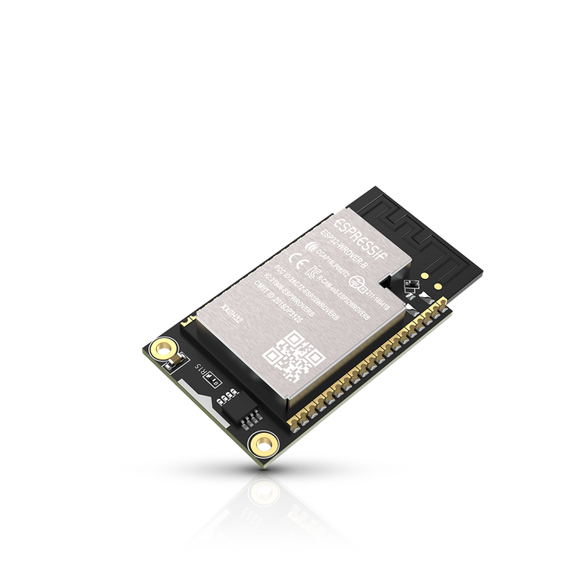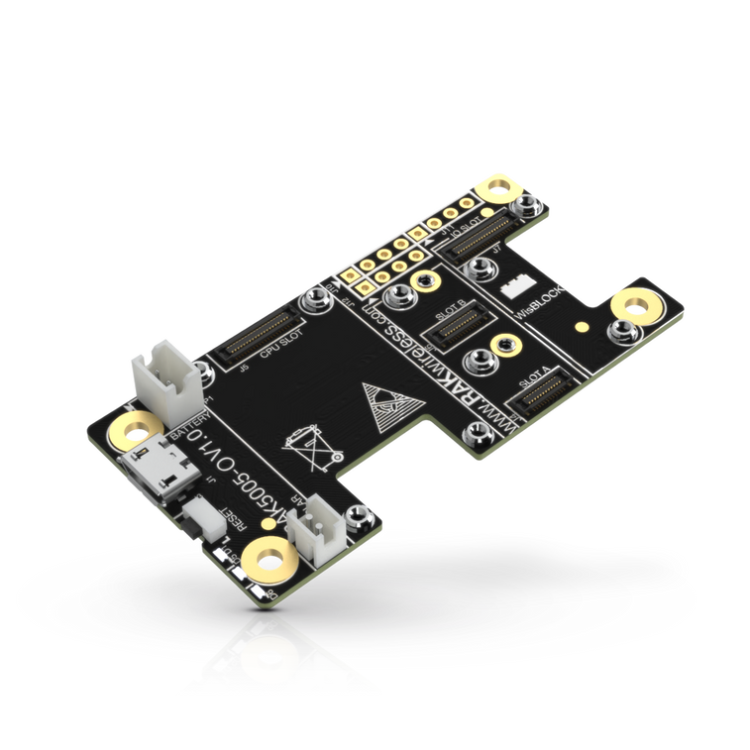

Rak Wisblock 11200. Rak Wisblock Base Board.

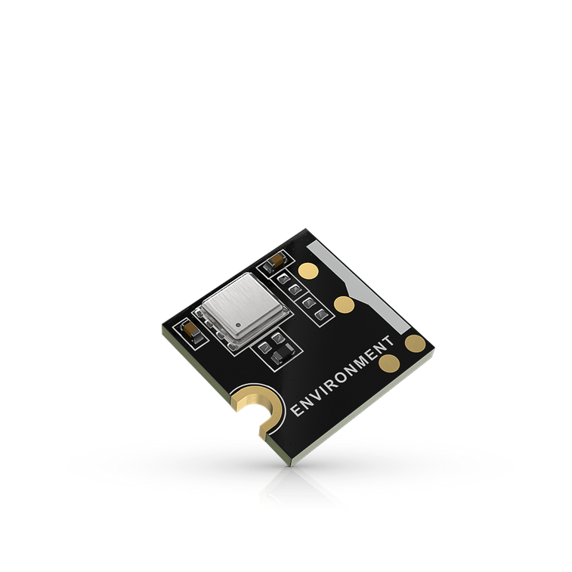
Rak 1906 Environmental sensor.

For this whole course, trust me, that's all you'll need.

Course Outline:

Module 01 : Getting Started with Qubitro……………………………………………05

Module 02 : Setting up a Hardware Unit……………….……………………………. 07

Module 03 : Configuring the Hardware Unit……………………….……………… 08

Module 04 :Visualizing the Hardware Data………………………….………………09

Getting Started with Qubitro:

Getting started with Qubitro:

What is Qubitro:

If you're an IoT developer or a do-it-yourself hobbyist, how do you choose your IoT Cloud platform? There are a lot of them out there, but picking the appropriate one is more challenging because you have to consider a lot of factors, from your budget to your time. Consider what would happen if your client requested a separate application to control your IoT product, or if he requested a web or mobile application to expose his data to the public. How are you going to do it? Customers are always our top priority, and we must ensure that they are satisfied. We recognise you already devote a significant amount of effort to developing your IoT solution, and we don't want you to waste time designing dashboards, APIs, and other features.

Qubitro is the fastest way to build IoT applications with predictable pricing,
developer-friendly features, and scalability you’ll definitely love.



Just checkout : https://qubitro.com/

Create a free Qubitro account:

Simply type qubitro.com into your browser, ta da !! we will be there.

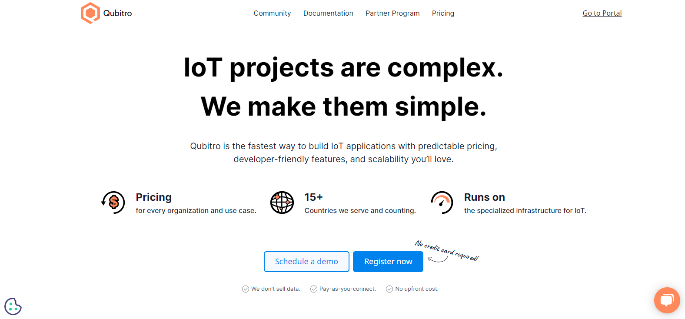
[Qubitro Home Page]

You will be seen like a web page like above one, click on Register Now and create a new account.

Now you are ready to built the strong and futuristic IoT platform.

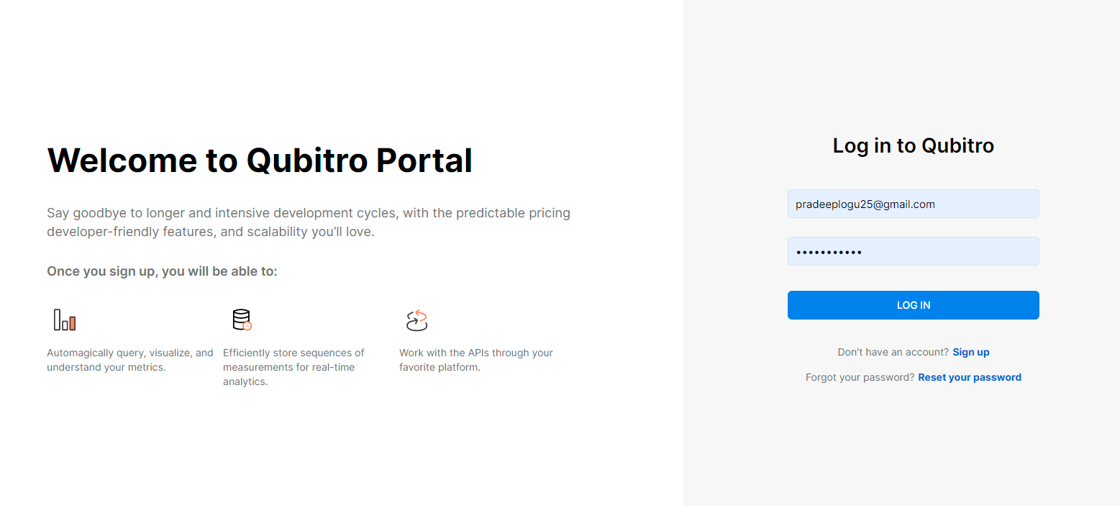
[Qubitro Portal Page]

Once you opened the portal It will ask for you to create a new project. Type your project name and your project description.

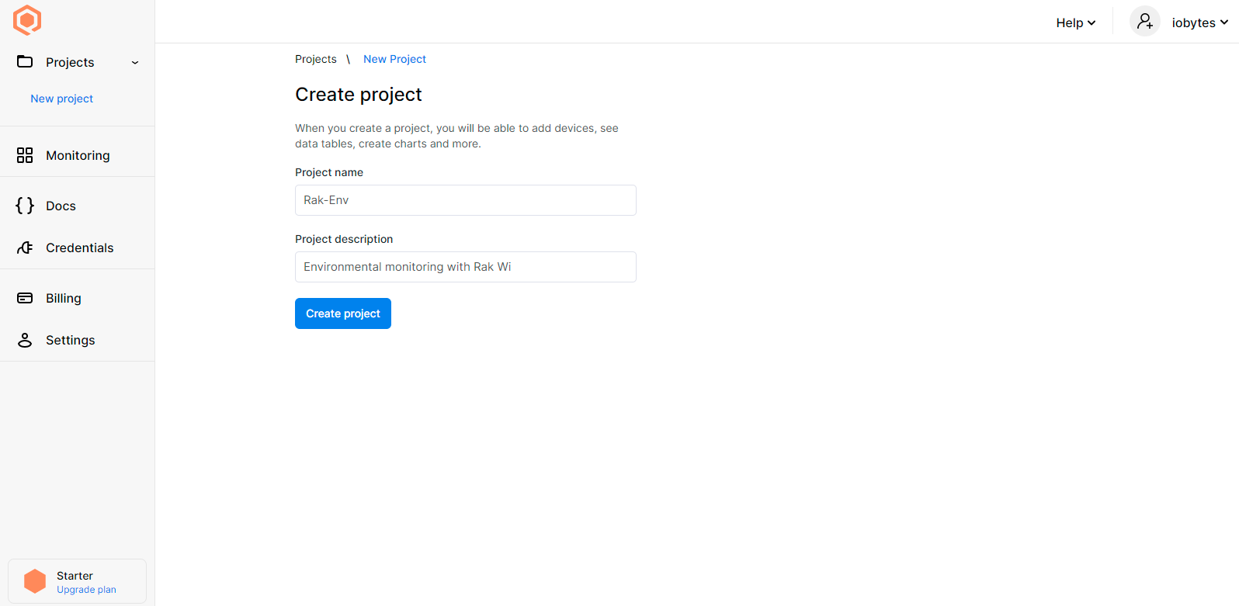
[Create Project Page]

Qubitro allows you to setting up multiple connectivity options like MQTT, TTN, Blues Notehub, Helium and Actility. In this demo we are going to set up a MQTT Connection, so choose the MQTT and hit continue.
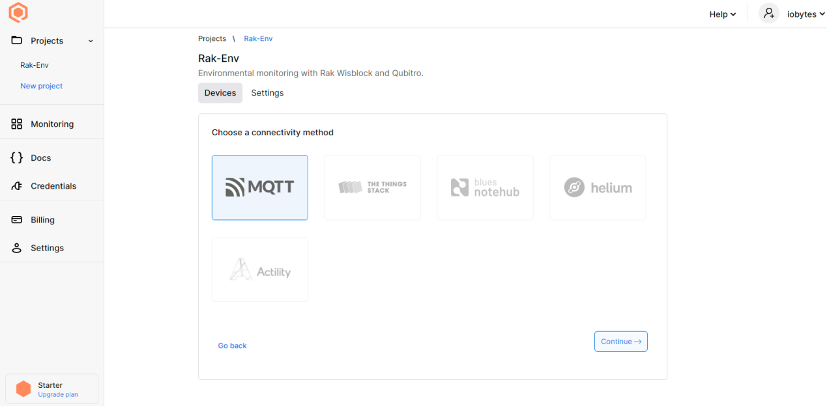
[Connectivity Page]

Now you need to add your first device to the portal click on add device.

Enter the all needed device details.

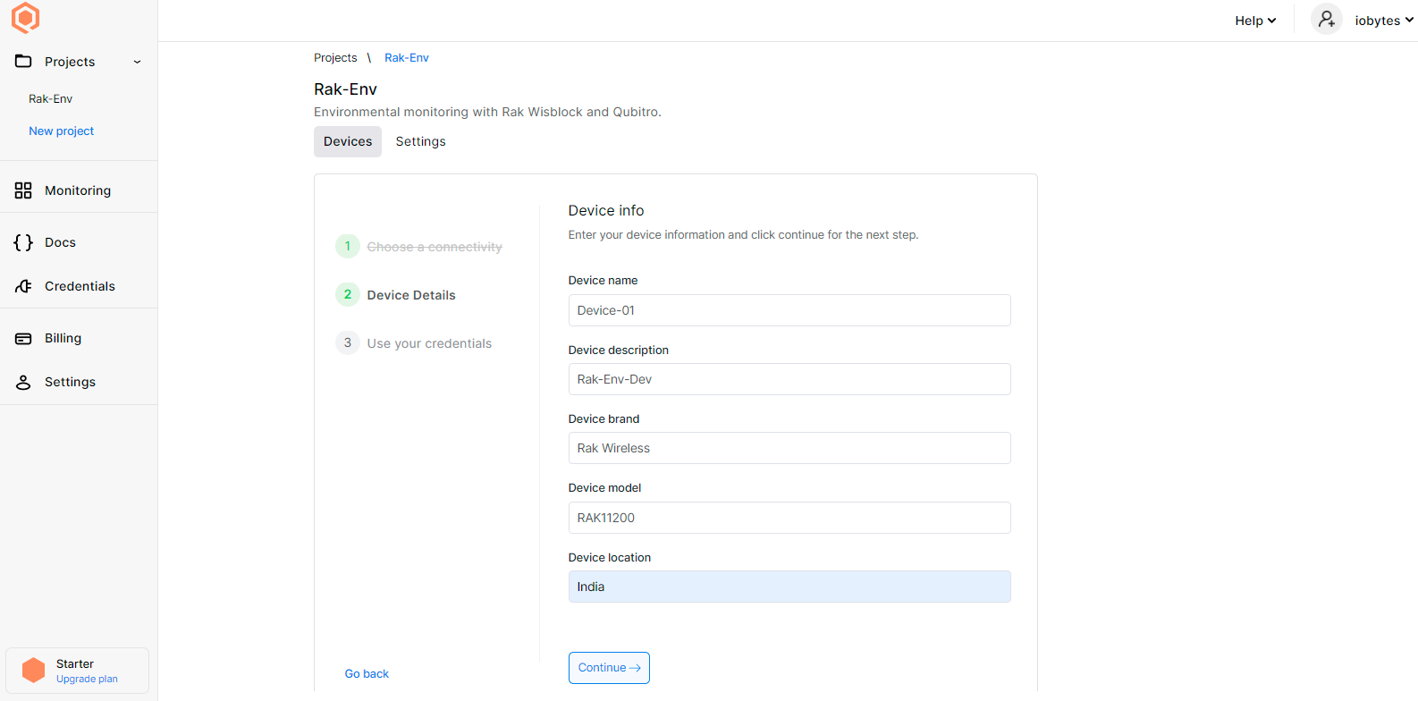
[Add Device Page]

Once you enter all the necessary information’s, click continue and it will show you the MQTT Connection credentials, save these because we need this for our next module.

Now all the setups were completed, let's jump into Hardware part.

Setting up a Hardware Unit:

Setting up a Hardware Unit:

Rak WisBlock:

For this whole demo we will gonna use Rak Wisblock Base board and ESP32 Core, We (Qubitro) had a hardware partnership with Rak Wireless. In Rak Wireless they develop market-oriented and easy-to-use IoT Building Blocks of MCUs, communication modules, and sensors in a Modular IoT platform system. That means you can accelerate the time of your IoT application to develop from prototype to commercial.

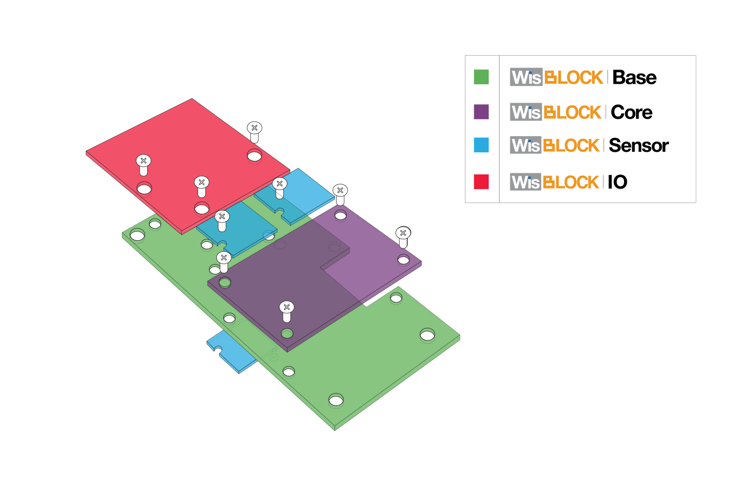

Rak Wisblock Base Board :
[Rak Wisblock Base Board]

WisBlock Base Board (RAK5005-O) is the base block for RAK WisBlock. It is the carrier for the WisBlock Core MCU module and the WisBlock Sensor and Modules from other WisBlock Categories. It enables the engineers and makers to build with low-effort prototypes, test different types of sensors, and develop the application. And because all components and modules of WisBlock are industrial rated the step from development to mass production is no problem.
WisBlock Base Board supports as standard 3 different power supplies. Depending on the application either 5V USB, 3.7V LiPo batteries, and 5V solar panels or a combination can be chosen. WisBlock Base Board enables low power consumption applications with the option to switch

on and off the power supply for the WisBlock Sensor and from another WisBlock category with slots.

Rak Wisblock 11200 - ESP32 Core :

[Rak Wisblock 11200]

RAK11200 is a WisBlock Core module for RAK WisBlock based on Espressif ESP32-WROVER. It is a powerful, generic WiFi-BLE MCU module that targets a wide variety of applications. There are two CPU cores that can be individually controlled and the CPU clock frequency is adjustable from 80 MHz to 240 MHz. The low-power deep-sleep current consumption of the ESP32-WROVER is about 10 uA. This makes the RAK11200 an ultra-low-power communication

solution. RAK11200 can be comfortably programmed with the Arduino IDE or PlatformIO.

Rak1906 Environmental sensor :

[Rak 1906]

The RAK1906 WisBlock Environmental Sensor module, part of the RAK WisBlock Sensor series, is a 4-in-1 digital sensor board that comprises gas, humidity pressure, and temperature sensor, based on the Bosch® BME680 module. The RAK1906 is ideal for applications such as indoor air quality, home automation, and building IoT solutions.

Arduino IDE Installation :

Follow this link to install the Arduino IDE on your PC.

Arduino IDE BSP Installation :

Install RAKWireless ESP32 BSP on Arduino Boards Manager :
To add board support for RAK11200 on Arduino, start Arduino IDE and open the Preferences window (File > Preferences).
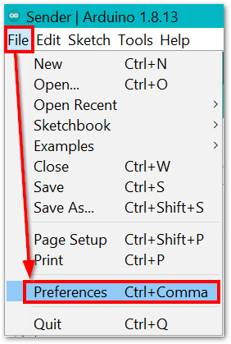
[Arduino File Preferences Window]

In the Preferences window, look for Additional Boards Manager URLs and click the icon on the right side.
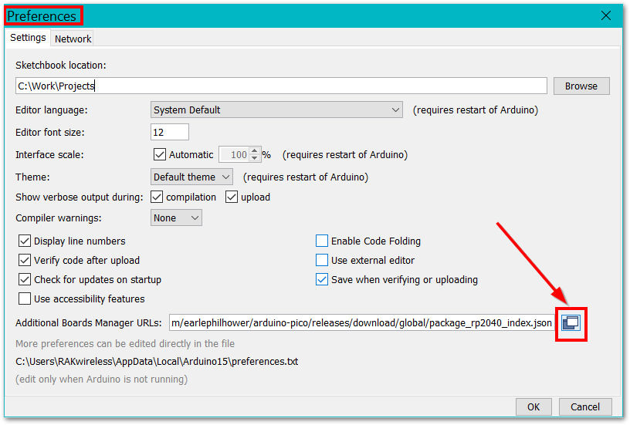
[Arduino Preferences]
[ https://raw.githubusercontent.com/RAKwireless/RAKwireless-Arduino-BSP-Index/main/package_rakwireless_index.json ]
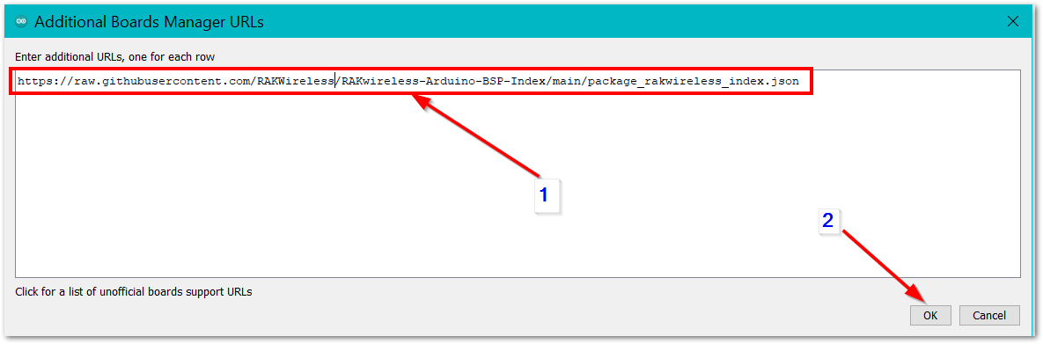
[Arduino Additional Boards Manager URLs]

Next, open the Boards Manager in the menu Tools.
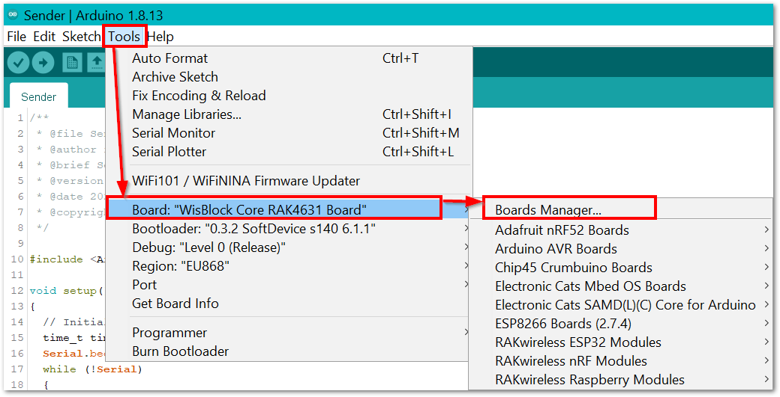
[Arduino Boards Manager]
Type RAK in the search bar. The RAKwireless WisBlock Core modules will be shown in the window.
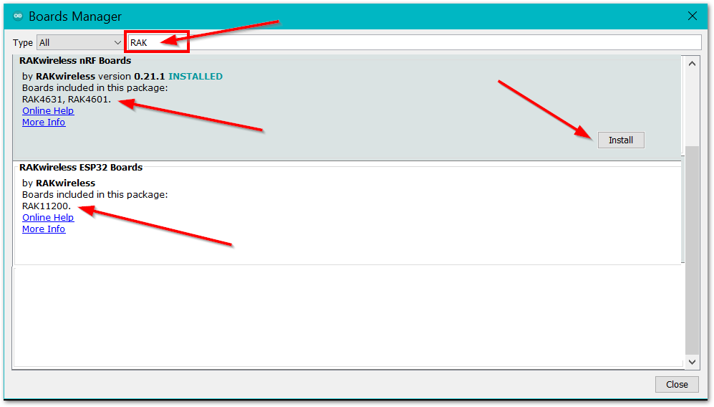
[Arduino Tools Boards Manager]
Select RAKwireless ESP32 Boards and click on Install button.

Compiling a Project :
The compiling process is very easy, what you need to do is just to click the Verify/Compile button on Arduino IDE.
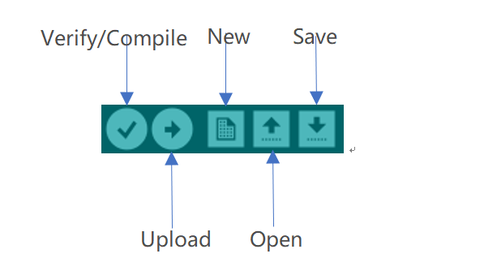
[Arduino Verify/Compile]
After compiling successfully, you can see some information in the output message area, and the state is "Done compiling.":
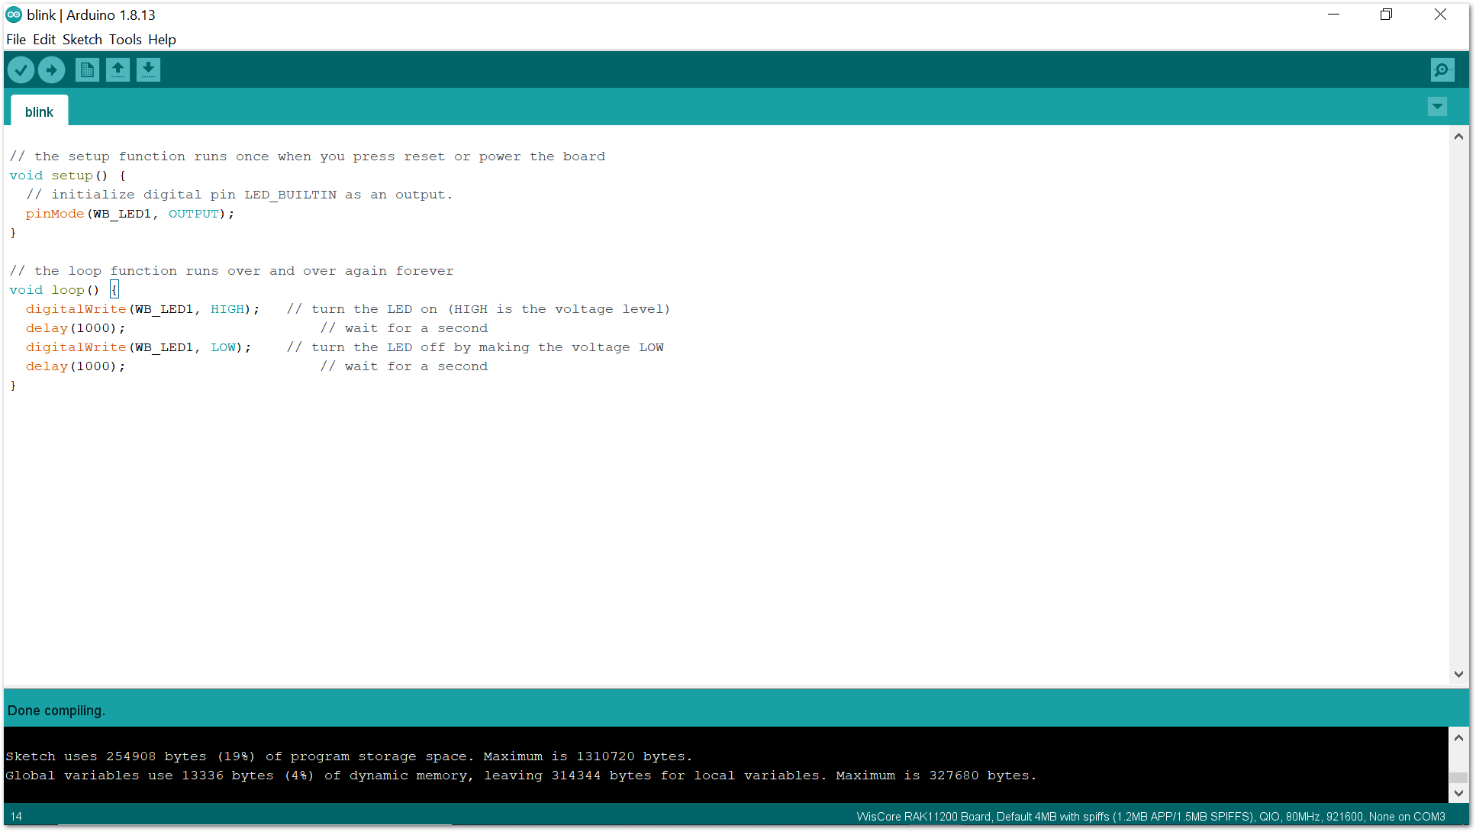
[Arduino Done compiling]

Now, you can connect your WisBlock hardware with your PC, and upload the code into it.

Uploading to WisBlock :

Make sure that your WisBlock hardware has been connected with your PC correctly, and your PC has recognized WisBlock hardware successfully. If it is, you can select the board and port now.
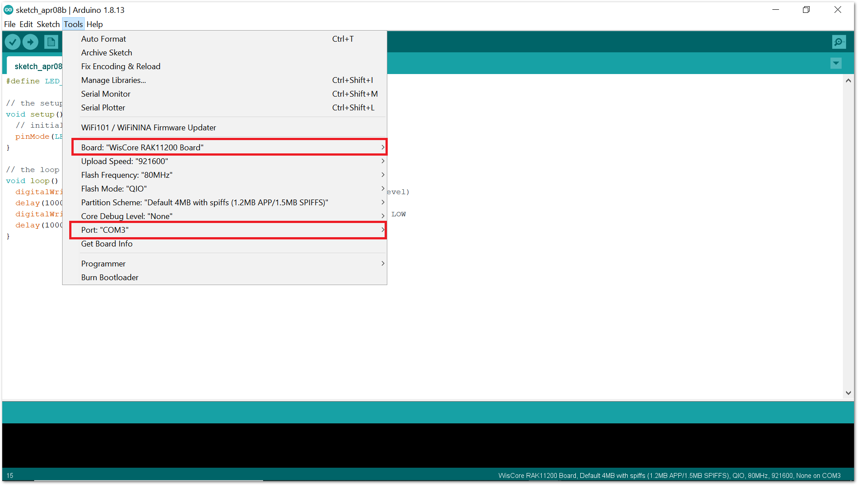
[Arduino Tools Configuration]

Before uploading your sketch, short circuit BOOT0 and GND pin and press the reset button. Then click the Upload button using the configuration below.
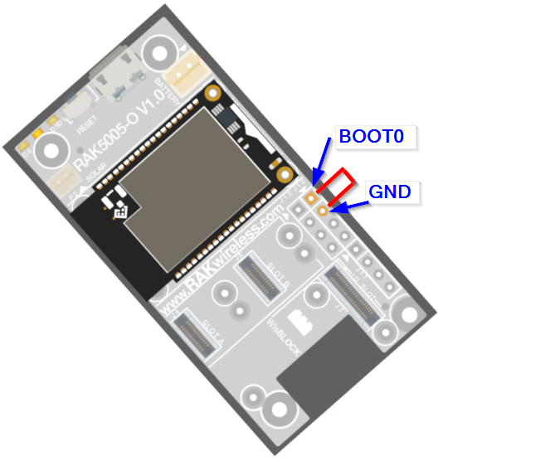
[Force ESP32 Download mode]
After uploading successfully, push the reset button. Then you can see some information in the output message area. That means you've uploaded the code into RAK11200 successfully.
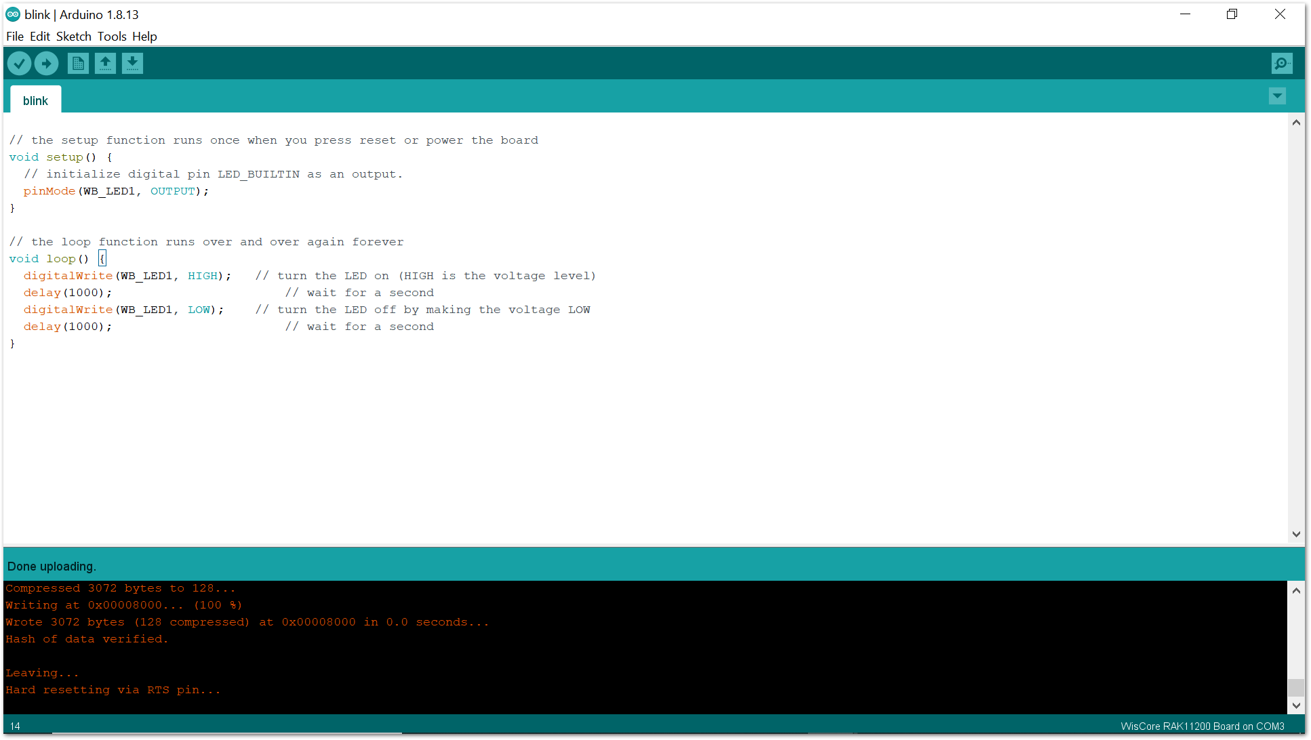
[Arduino Done uploading]

